**PROJECT TITLE:** The Website Traffic Analysis

**Project Definition:** The project involves analysing website traffic data to gain insights into user behaviour, popular pages, and traffic sources. The goal is to help website owners enhance the user experience by understanding how visitors interact with the site. This project encompasses defining the analysis objectives, collecting website traffic data, using IBM Cognos for data visualization, and integrating Python code for advanced analysis.

**Project Objective:**

Web traffic analysis is the process of collecting and analyzing data about the visitors and their behavior on a website. The objective of web traffic analysis is to understand how the website is performing, how to optimize it for better user experience, and how to increase conversions and revenue. Some of the common metrics used for web traffic analysis are: **Sessions**: The number of times users interact with the website within a given time period.

* **Pageviews**: The number of times users view a page on the website.
* **Bounce rate**: The percentage of sessions that end after viewing only one page on the website.
* **Conversion rate**: The percentage of sessions that result in a desired action, such as making a purchase, signing up for a newsletter, or filling out a form.

**Design Thinking:**

1. Analysis Objectives: Define the key insights you want to extract from the website traffic data, such as identifying popular pages, traffic trends, and user engagement metrics.
2. Data Collection: Determine the data sources and methods for collecting website traffic data, including page views, unique visitors, referral sources, and more.
3. Visualization: Plan how to visualize the insights using IBM Cognos to create meaningful dashboards and reports.
4. Python Integration: Consider incorporating machine learning models to predict future traffic trends or user behaviour pattern.

**Development Phase**

# Define Analysis Objectives:

Start by discussing the project objectives with the website owners or stakeholders. Understand their specific goals and expectations from the analysis.

Clearly define what insights you want to extract from the website traffic data. For example, you may want to understand user demographics, behaviour patterns, or conversion rates.

# Data Collection:

Identify the data sources for website traffic data. Common sources include Google Analytics, server logs, or other web analytics tools.

Set up data collection mechanisms to gather relevant data, ensuring that you capture the necessary metrics (e.g., page views, sessions, bounce rates, referral URLs, user agents).

# Data Preparation:

Clean and preprocess the collected data to ensure it is accurate and consistent. This may involve handling missing values, removing duplicates, and transforming data as needed. Store the data securely in a structured format for analysis.

# Data Visualization with IBM Cognos:

Use IBM Cognos or a similar data visualization tool to create visualizations and dashboards that provide insights into user behaviour, popular pages, and traffic sources. Generate charts, graphs, and reports that make it easy for stakeholders to interpret and derive insights from the data.

# Advanced Analysis with Python:

Integrate Python into your analysis process to perform more advanced tasks, such as: Clustering users based on behaviour.

Predicting user conversions. Analysing traffic trends over time.

Write Python code to extract data from your data storage, perform analysis, and generate additional insights beyond what can be achieved with IBM Cognos alone.

# Insights and Recommendations:

Analyse the results from both the data visualization tool and your Python-based analysis to derive actionable insights.

Based on these insights, provide recommendations to the website owners for improving the user experience. These recommendations should be data-driven and tailored to the specific findings.

# Implementation and Monitoring:

Work with website owners to implement the recommended changes or enhancements to the website.

Continuously monitor the impact of these changes on user behavior and website performance.

# Documentation and Reporting:

Document your analysis process, findings, and recommendations in a clear and concise manner.

Create reports and presentations that can be shared with stakeholders.

# Iterate and Improve:

Website analytics is an ongoing process. Regularly update your analysis as new data becomes available and refine your recommendations based on evolving user behaviour and trends.

Throughout the project, it's essential to maintain data privacy and security, adhere to relevant regulations, and ensure that sensitive user information is handled responsibly. Additionally, effective communication with stakeholders is critical to ensure that the analysis results in meaningful improvements to the website's user experience.

**VISUALIZATION USING IBM COGNOS ANALAYTICS BEFORE PREPROCESSING**

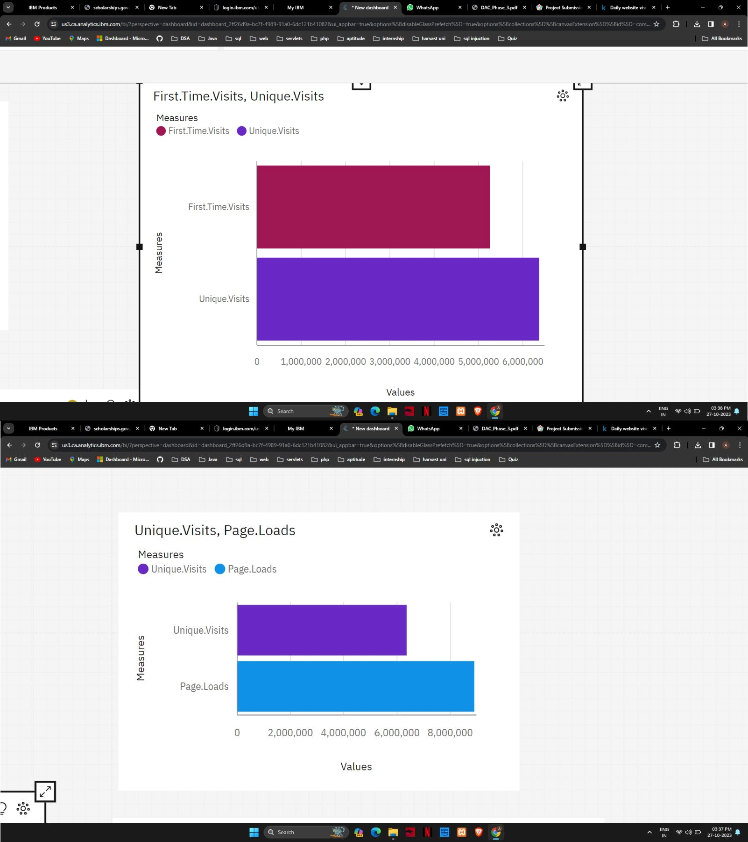

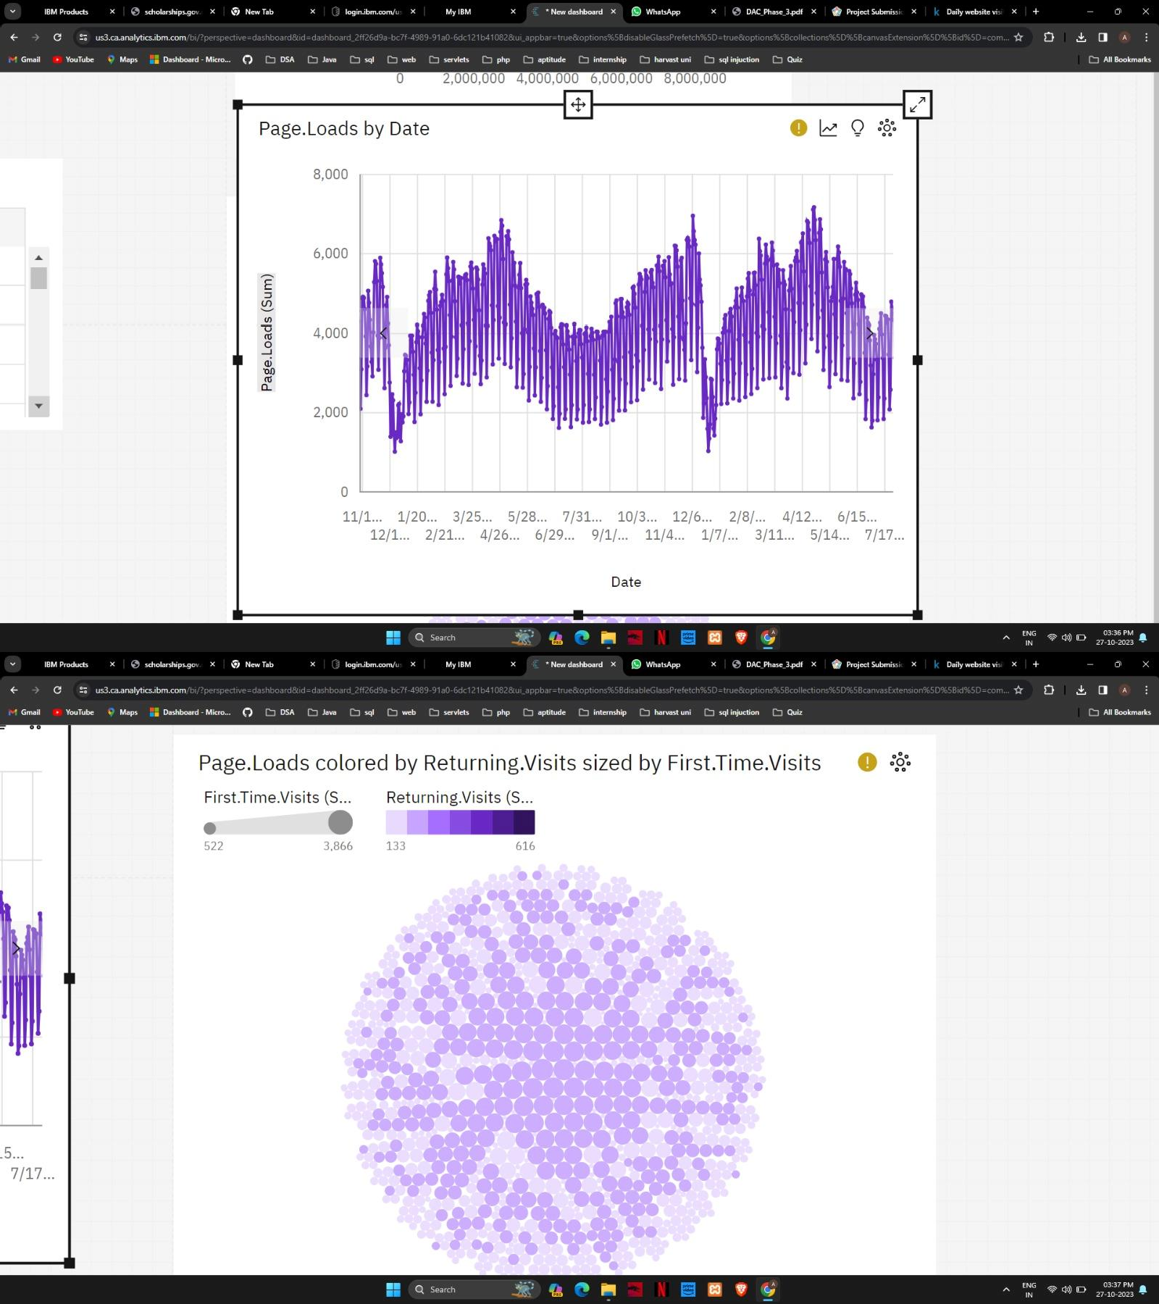

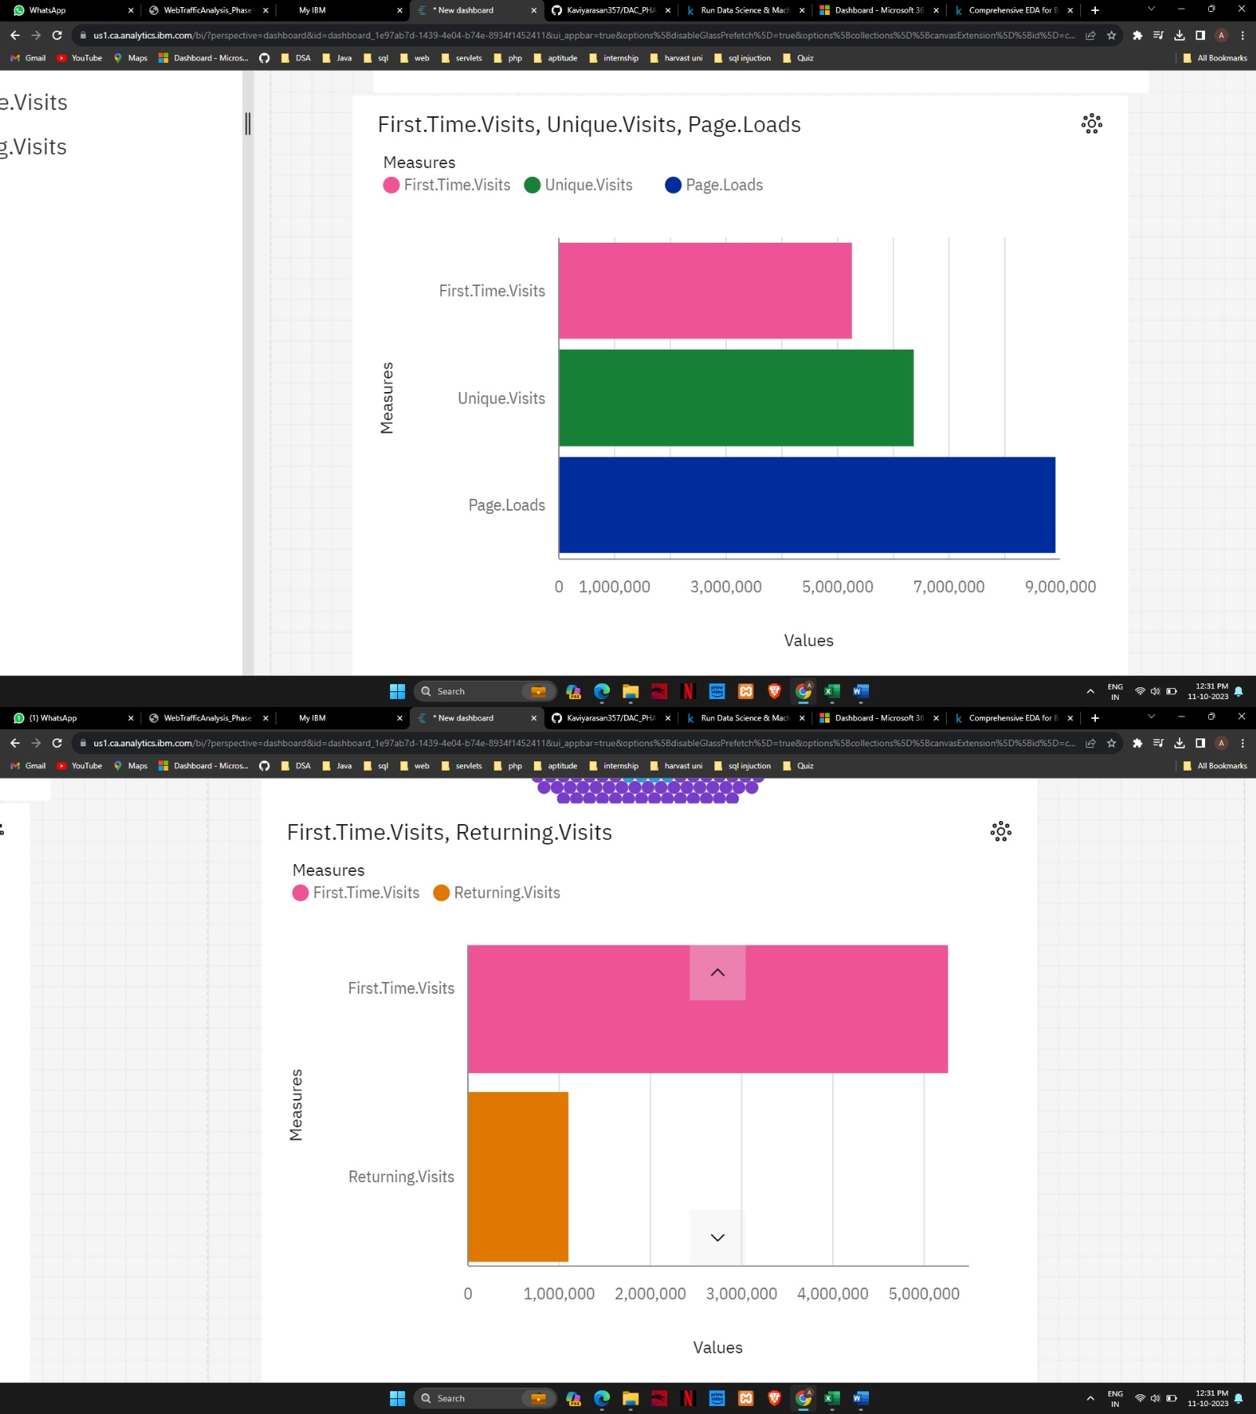

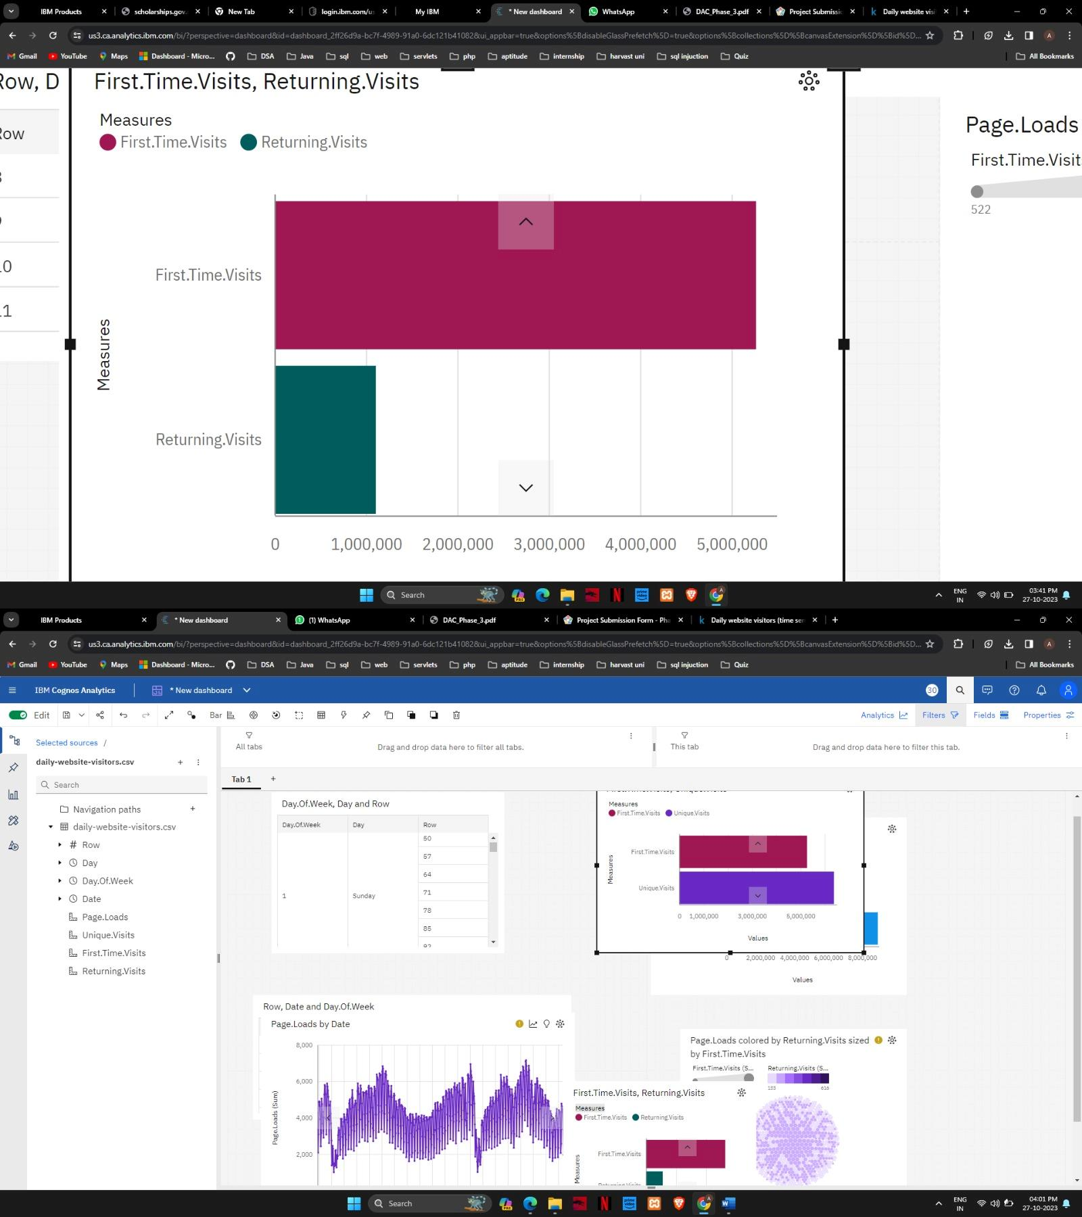

**DATA PREPROCESSING USING PYTHON**

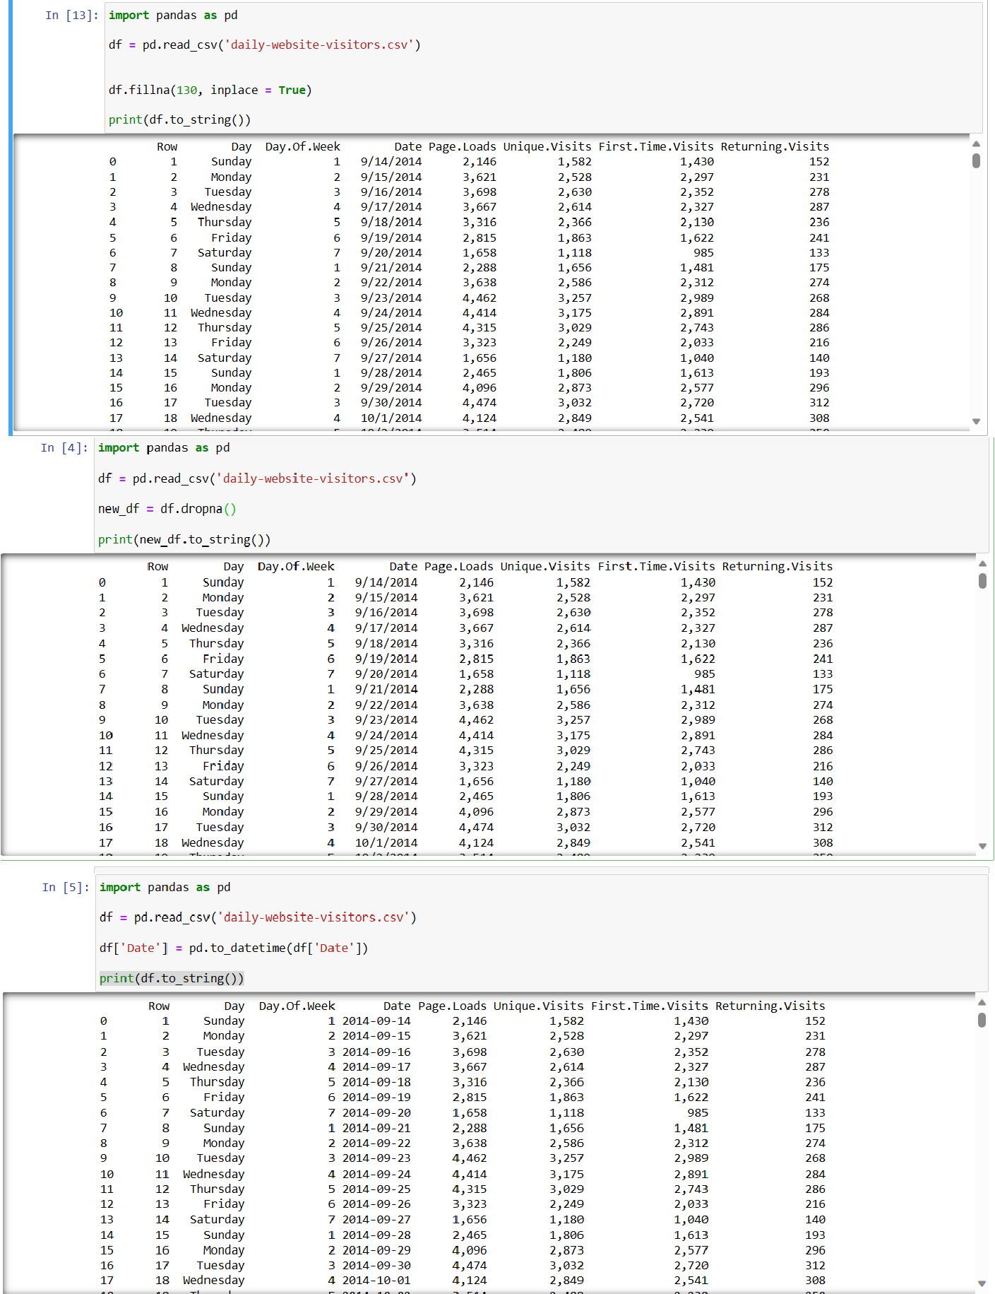

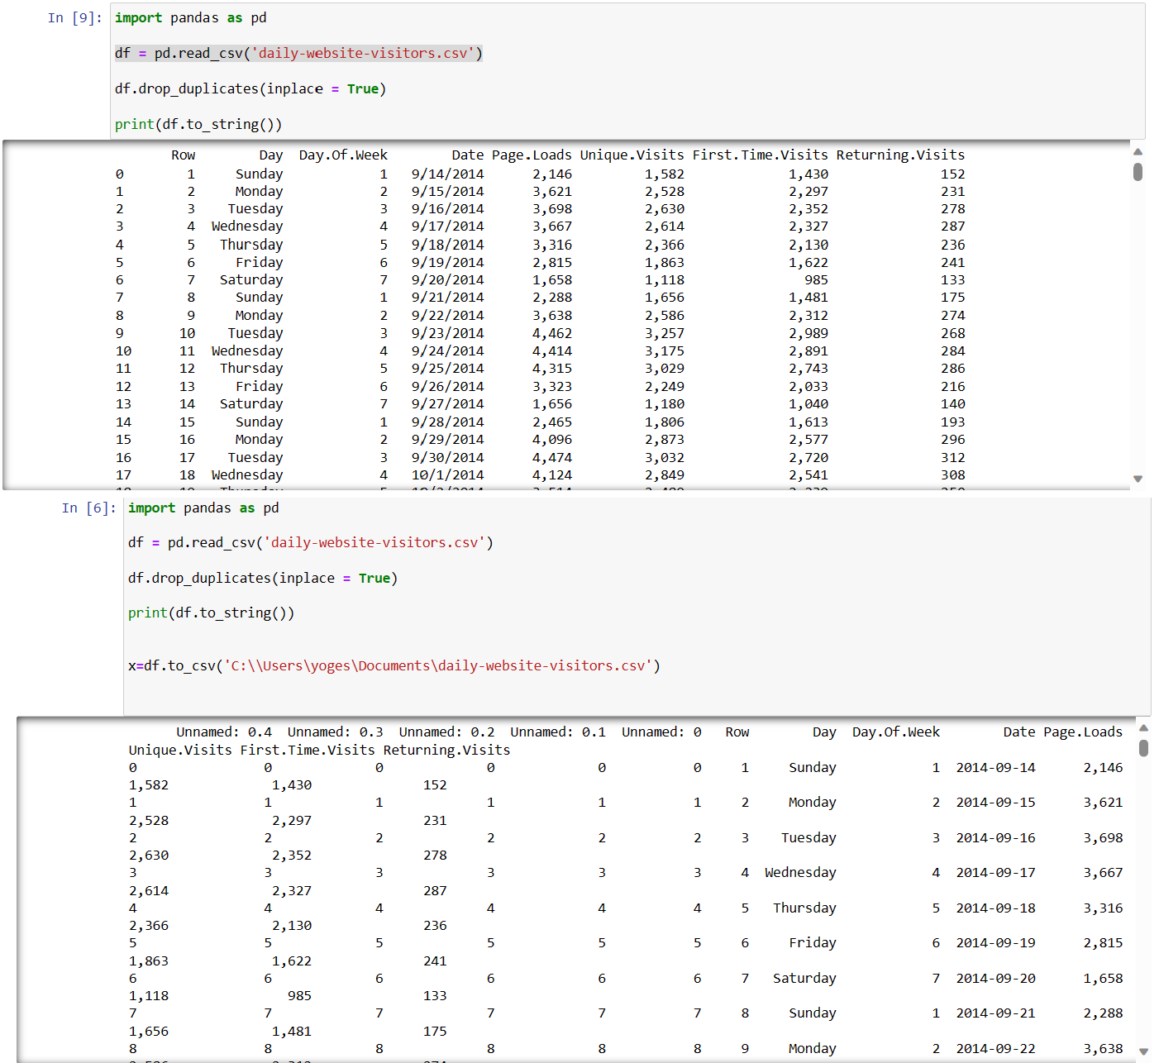

**VISUALATION USING IBM COGNOS ANALYTICS AFTER DATA PREPROCESSING**

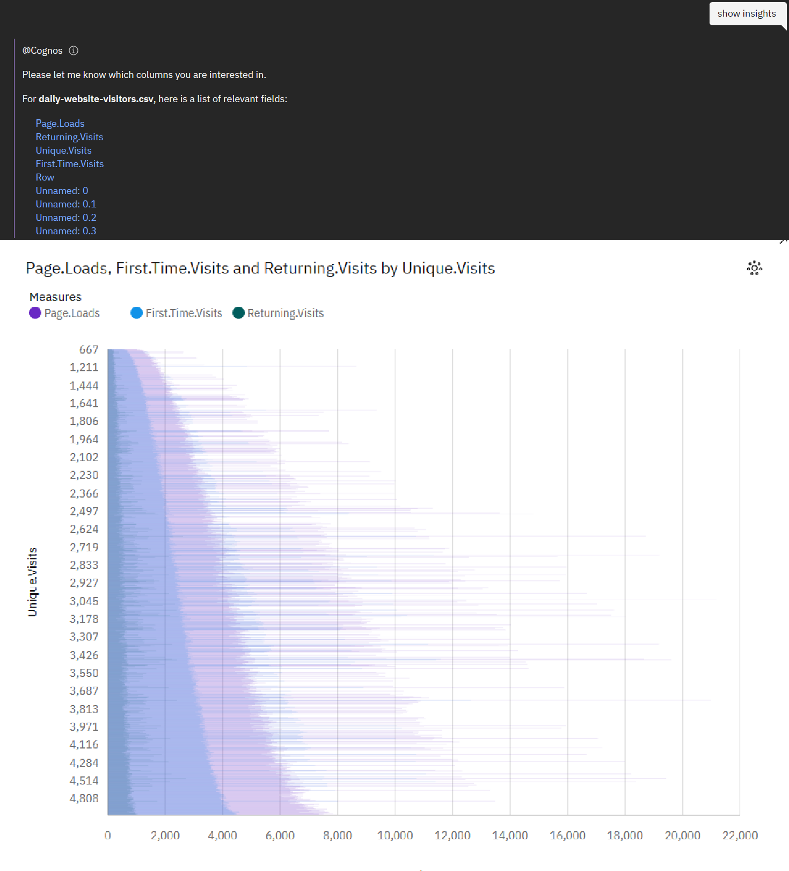

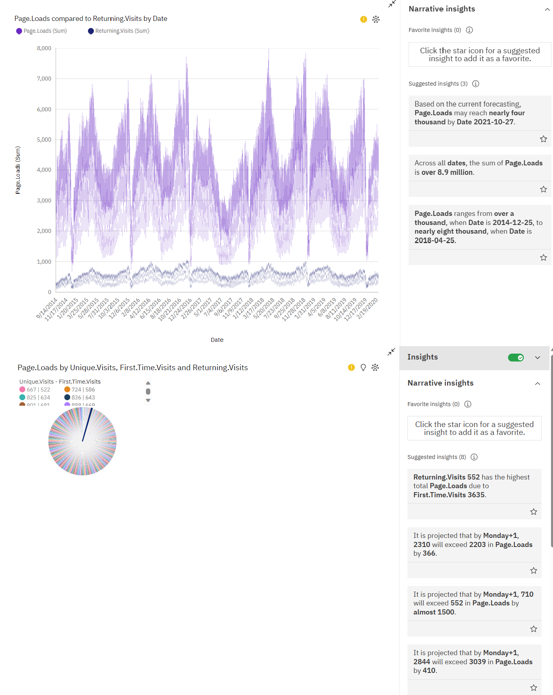

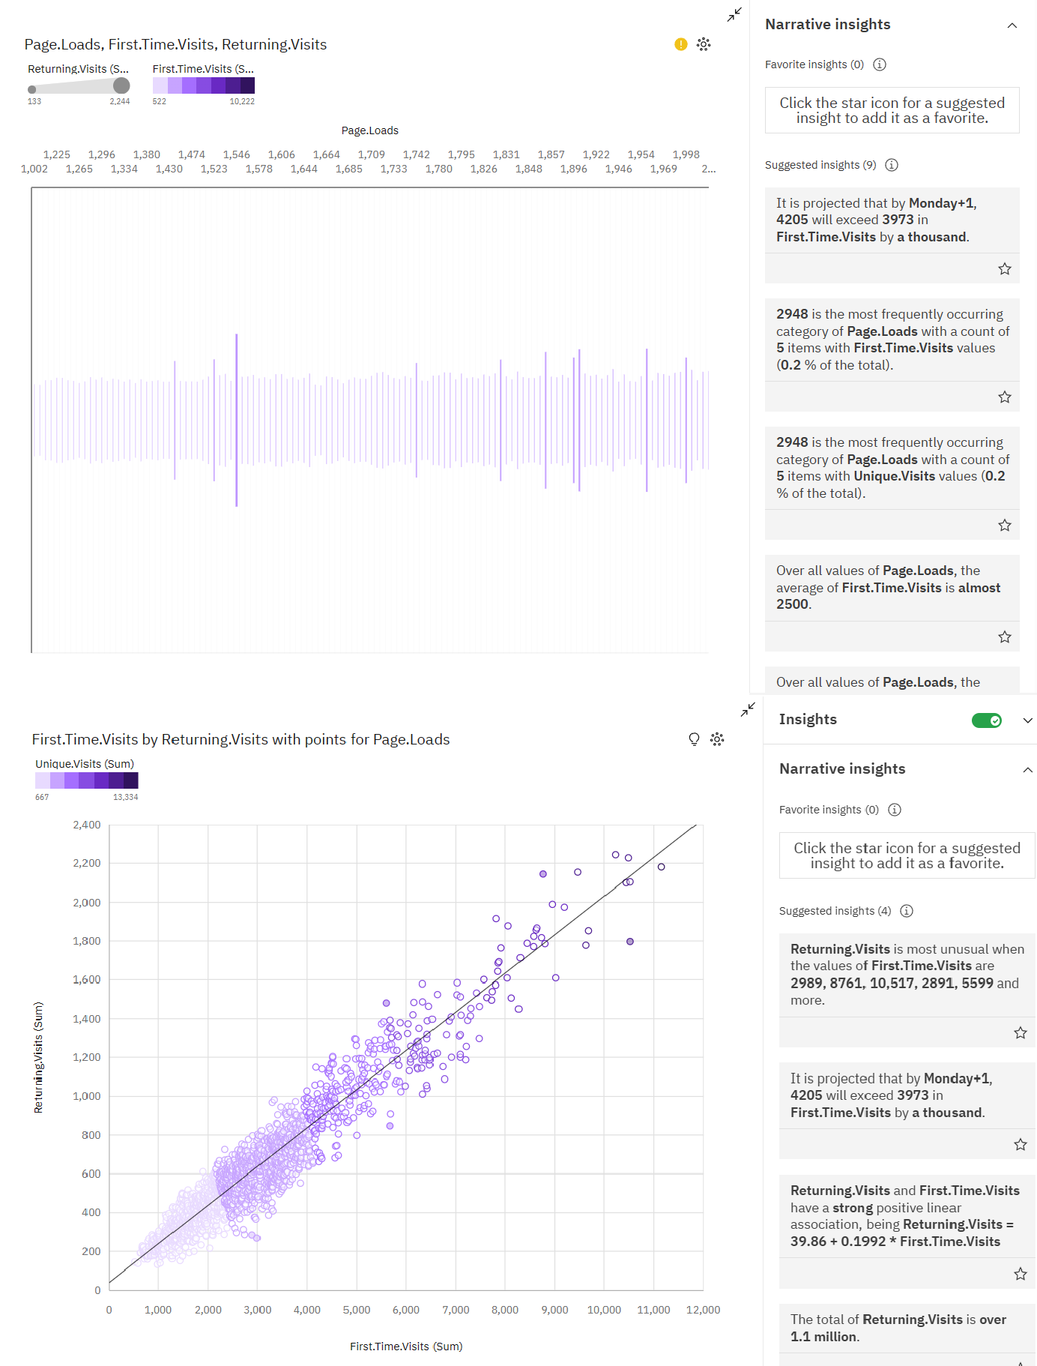

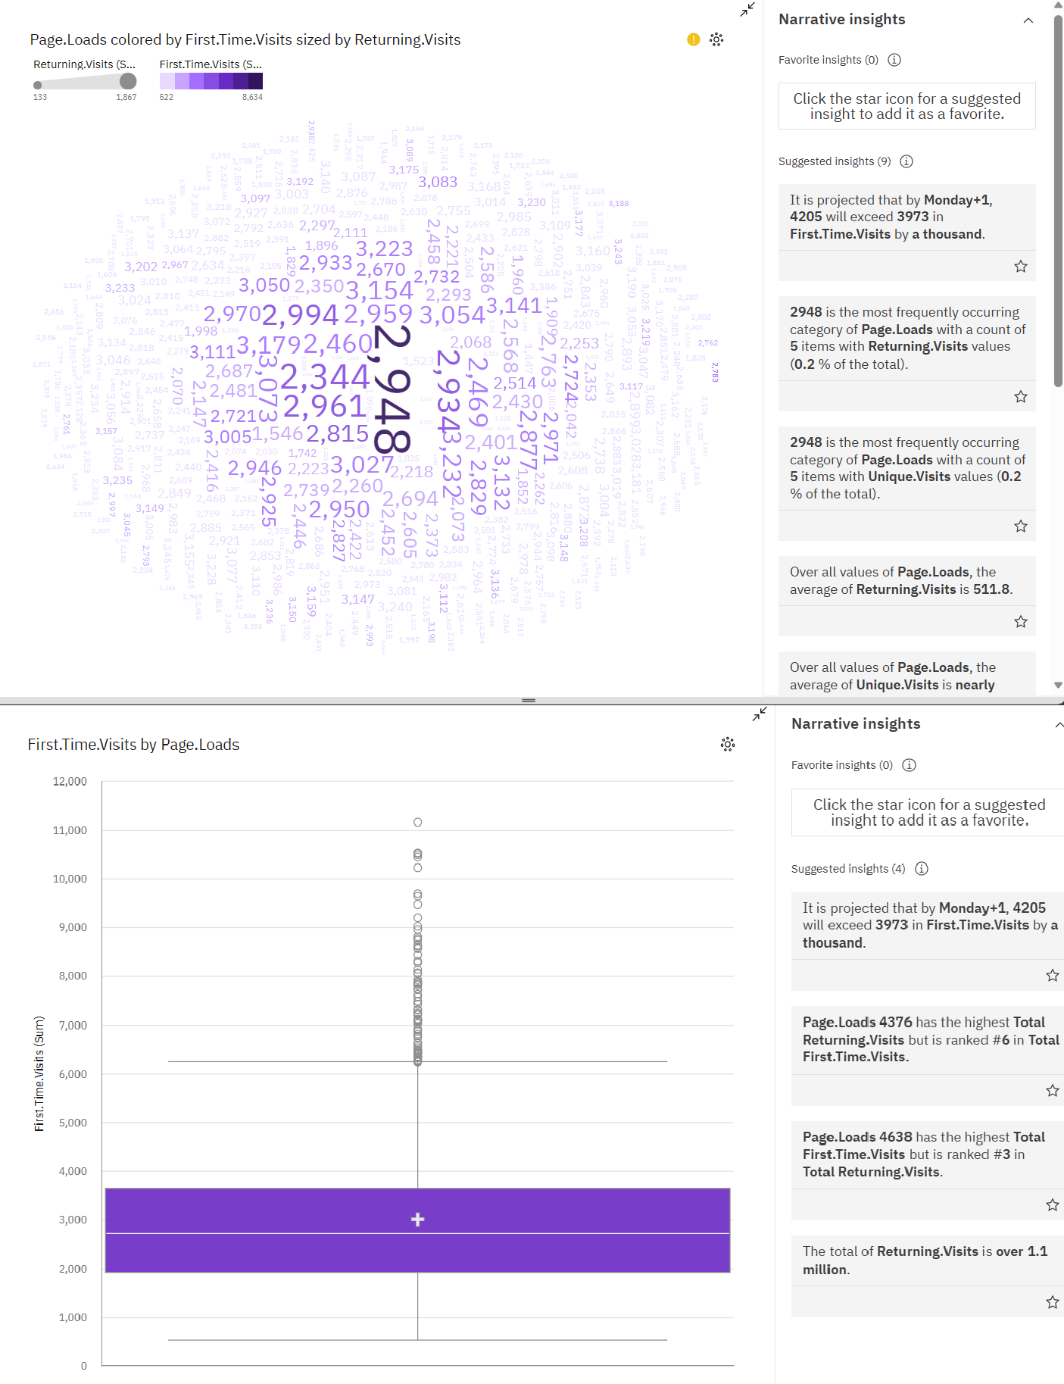

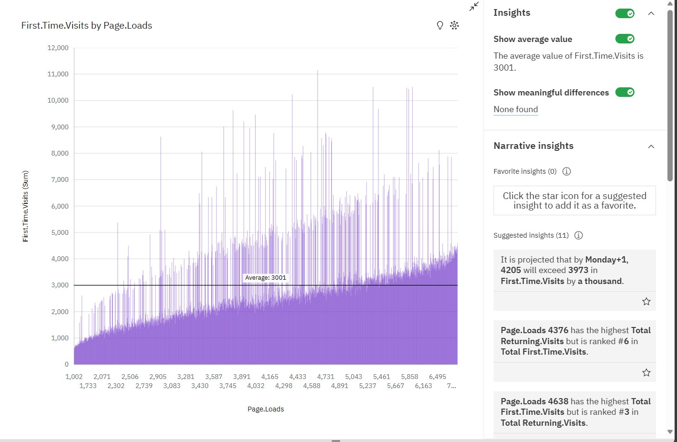

Website traffic analysis provides valuable insights that can significantly benefit the website owner. Here's how these insights can help the owner improve their website and enhance the overall visitor experience:

# Understanding Audience Behavior:

Insight: Analyzing user behavior helps the owner understand what visitors are looking for on their site.

Benefit: By knowing what users want, the owner can tailor content, products, or services to meet visitor needs effectively.

# Identifying Popular Content:

Insight: Knowing which pages or posts are popular indicates what resonates with the audience.

Benefit: The owner can create more content similar to the popular ones, increasing user engagement and time spent on the website.

# Improving User Experience:

Insight: Analyzing exit pages and bounce rates helps identify weak points in the user journey.

Benefit: By enhancing these pages or providing clearer calls to action, the owner can reduce bounce rates and improve conversion rates.

# Optimizing Marketing Strategies:

Insight: Understanding traffic sources helps the owner identify which marketing channels are most effective.

Benefit: Focus marketing efforts and budget on channels that bring in high-quality traffic, leading to better ROI.

can rank higher in search engine results, increasing visibility and organic traffic.

# Data-Driven Decision Making:

Insight: Regular reports and data trends provide a basis for decision-making.

Benefit: The owner can make informed decisions on content, marketing, and user experience, leading to a more effective website strategy.

# Enhancing User Engagement:

Insight: Analyzing user interactions with multimedia and interactive content.

Benefit: By creating more engaging multimedia content, the owner can increase user interaction and time spent on the website.

# Staying Competitive:

Insight: Benchmarking against competitors provides context for performance.

Benefit: Understanding how the website performs compared to competitors can inform strategies, helping the owner stay ahead in the market.

# CONCLUSION

In summary, website traffic analysis empowers the owner to make data-driven decisions, improve content, enhance user experience, and ultimately increase the website's effectiveness in achieving its goals, whether it's sales, lead generation, or content engagement.

